OME - APRIL 13/14 2018

Node.js Native AddOns from zero to hero

Nicola Del Gobbo

Who is Nicola Del Gobbo?



**Developer**



**N-API TEAM**

What is Node.js Native Add-on?

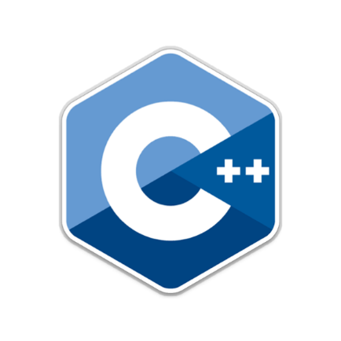

**C / C++** code called from JavaScript

BRIDGE

**Native** environment JavaScript

From Node.js documentation

*Node.js Addons are* ***dynamically-linked shared objects****, written in* ***C++****, that can be loaded into Node.js using the* ***require()*** *function, and used just as if they were an ordinary Node.js module.*

*They are used primarily to provide an* ***interface*** *between* ***JavaScript***

*running in Node.js and* ***C/C++*** *libraries.*

How is it possible?

All the **magic** is behind the **Node.js** architecture



**Performance**

In general **C / C++** code performs better than

JavaScript code, but it’s not always true.

**Image** processing (in average 6 times faster)

**Video** processing

**CRC** cyclic redundancy check (in average 125 times faster)

**Compression**

**Scientific calculus**

**Algorithms that execute CPU heavy tasks**

Why?

**Integrate legacy application**

You have the source code of an **old C / C++** application and want to expose something of its functionalities

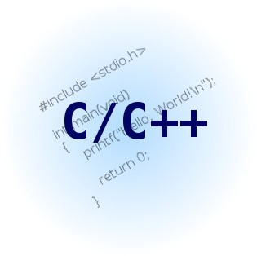

You don’t find what fits your specific needs on **npm**

Sometimes completely implementing the module in **JavaScript** is not the right solution

Think at libraries like: **ImageMagick Ghostscript FFmpeg TensorFlow**

**…**

**Better error handling**

Even if you will use **an old C / C++** library you will get an error code that explains the error that just happened

In **new C / C++** library you have the **exception**

You don’t have to parse some string to identify if there was an error and what kind of it

**With great power comes great responsibility**

Ben Parker

**Fragmentation API**

The API to implement native add-ons has been changed across different version of Node.js

Most of the changes were on **V8 API** and **ObjectWrap API**

**0.8 - 0.10.x - 0.12.x - 1.x - 2.x - 3.x - 4.x - 5.x - 6.x - 7.x - 8.x - 9.x**

For more info <http://v8docs.nodesource.com/>

Need an adapter to stay compatible across different

version of Node.js

• **NAN** - Native Abstraction for Node.js

• **API compatibility**

• Strong bonded with **V8 API**

• You have to recompile your native add-ons switching to different version of Node.js

**End user**

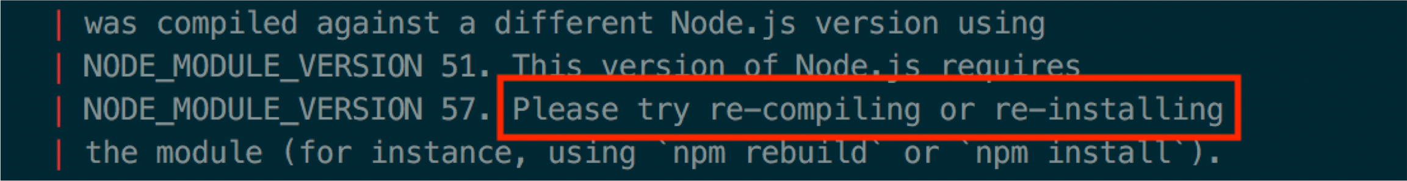

**Mantainers**

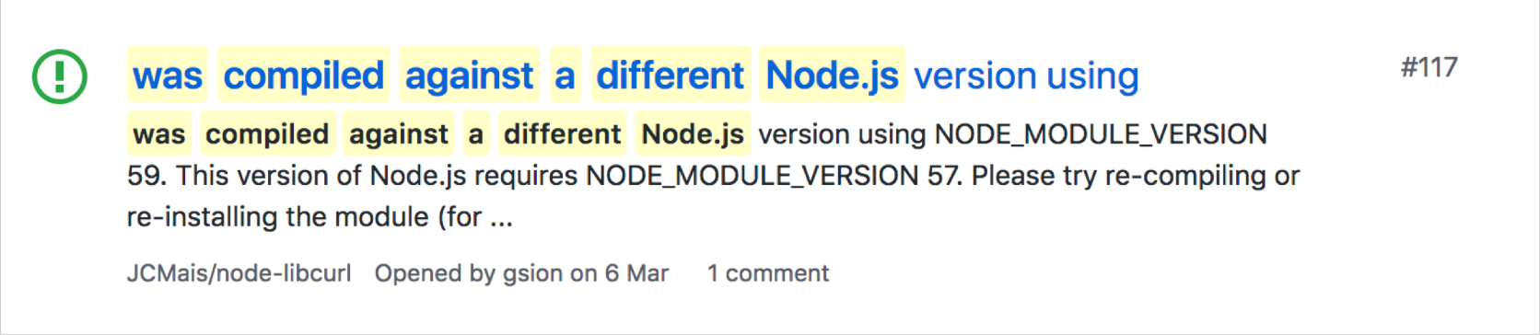

**Write portable C / C++ code**

Your native code **must compile and run** on different:

**ARCHITECTURE PLATFORM COMPILER**

**Documentation**

• **C / C++** libraries that you are integrating are not well documented

• There are good **references** but not so much practical guide focusing on complex concepts about native add-ons

N-API will be a game changer on the native add-on

development

• **API** and **ABI** compatibility

• **Isolated** from **V8** (VM agnostic)

• New **ES6** types

• C / C++ (only header wrapper)

• **Conversion** tool that helps to migrate from **NAN**

• **Generator** (help with initial scaffolding)

• Pre-builds (**node-pre-gyp** - **prebuildify**)

.. pass-buffer

_test_

build

.... lib index.js

node_modules

..,. ..; src deps

C•• binding.cc

C•• kvdb.cc

**h** kvdb.h

***i'*** binding.gyp

J index.js

[j[j[iil package-lock.json

[j[j[iil package.json

{

.. name..: ..echo-example..,

..version..: ..0.0.0..,

..description..: 11Node.js Addons - echo example..,

.. main..: 11 index.js..,

.. private..: true,

**npm will build the add-on automatically**

..gypfile11 : true,

..scripts: {

11 Start11 : 11 node index.js..

},

..dependencies..: {

.. node-addlon-api••:

.. bindings: 11 *11

11*11 ,

}

}

1 Import the add-on

canst addon = require('bindings•)('echo')

2 Call the add-on's function let myEcho = addon.echo(•Hey coders!•) console.log(myEcho)

**Example: the binding.gyp**

{

"targets" :

{ ----------------------------------------------

**Name used to register the addon**

"target_name" : "echo" ,

"sources" : [ "src/addon.cc"

],

'cflags! ' : [ '-fno-exceptions' 1,

'cflags_cc! ' : [ '-fno-exceptions' 1,

'include_dirs' : [ "<!@(node -p \" require('node-addon-api').include\" )"1,

'dependencies' : [ "<!(node -p \ " require('node-addon-api').gyp\" )"1,

'conditions' : [

[ 'OS=="win"' , { "msvs_settings" : {

"VCCLCompilerTool" : {

"ExceptionHandling" : 1

}

}

}],

[ 'OS=="mac"' , { "xcode_settings" : {

"CLANG_CXX_LIBRARY" : "libc++" ,

'GCC_ENABLE_CPP_EXCEPTIONS' : 'YES' ,

'MACOSX_DEPLOYMENT_TARGET' : '10.7'

}

}1

}

}

**Example: the** C *I* C++ **part**

Napi::Value Echo(const Napi::Callbackinfo& info) { Napi::Env env = info.Env();

3

**Validate your input- Execute operations on them- Return results**

if (info[0).IsString()) {

std::string in = info[0].As<Napi::String>();

return Napi::String::New(env, in);

}else {

throw Napi::Error::New(env, "The argument must be a string");

}

}

2 **Export objects and functions**

//*Init*

Napi::Object Init(Napi::Env env, Napi::Object exports) { exports.Set(Napi::String::New(env, "echo"), Napi::Function::New(env, Echo)); return exports;

}

**1 Registration and Initialization**

NODE_API_MODULE(NODE_GYP_MODULE_NAME, Init);

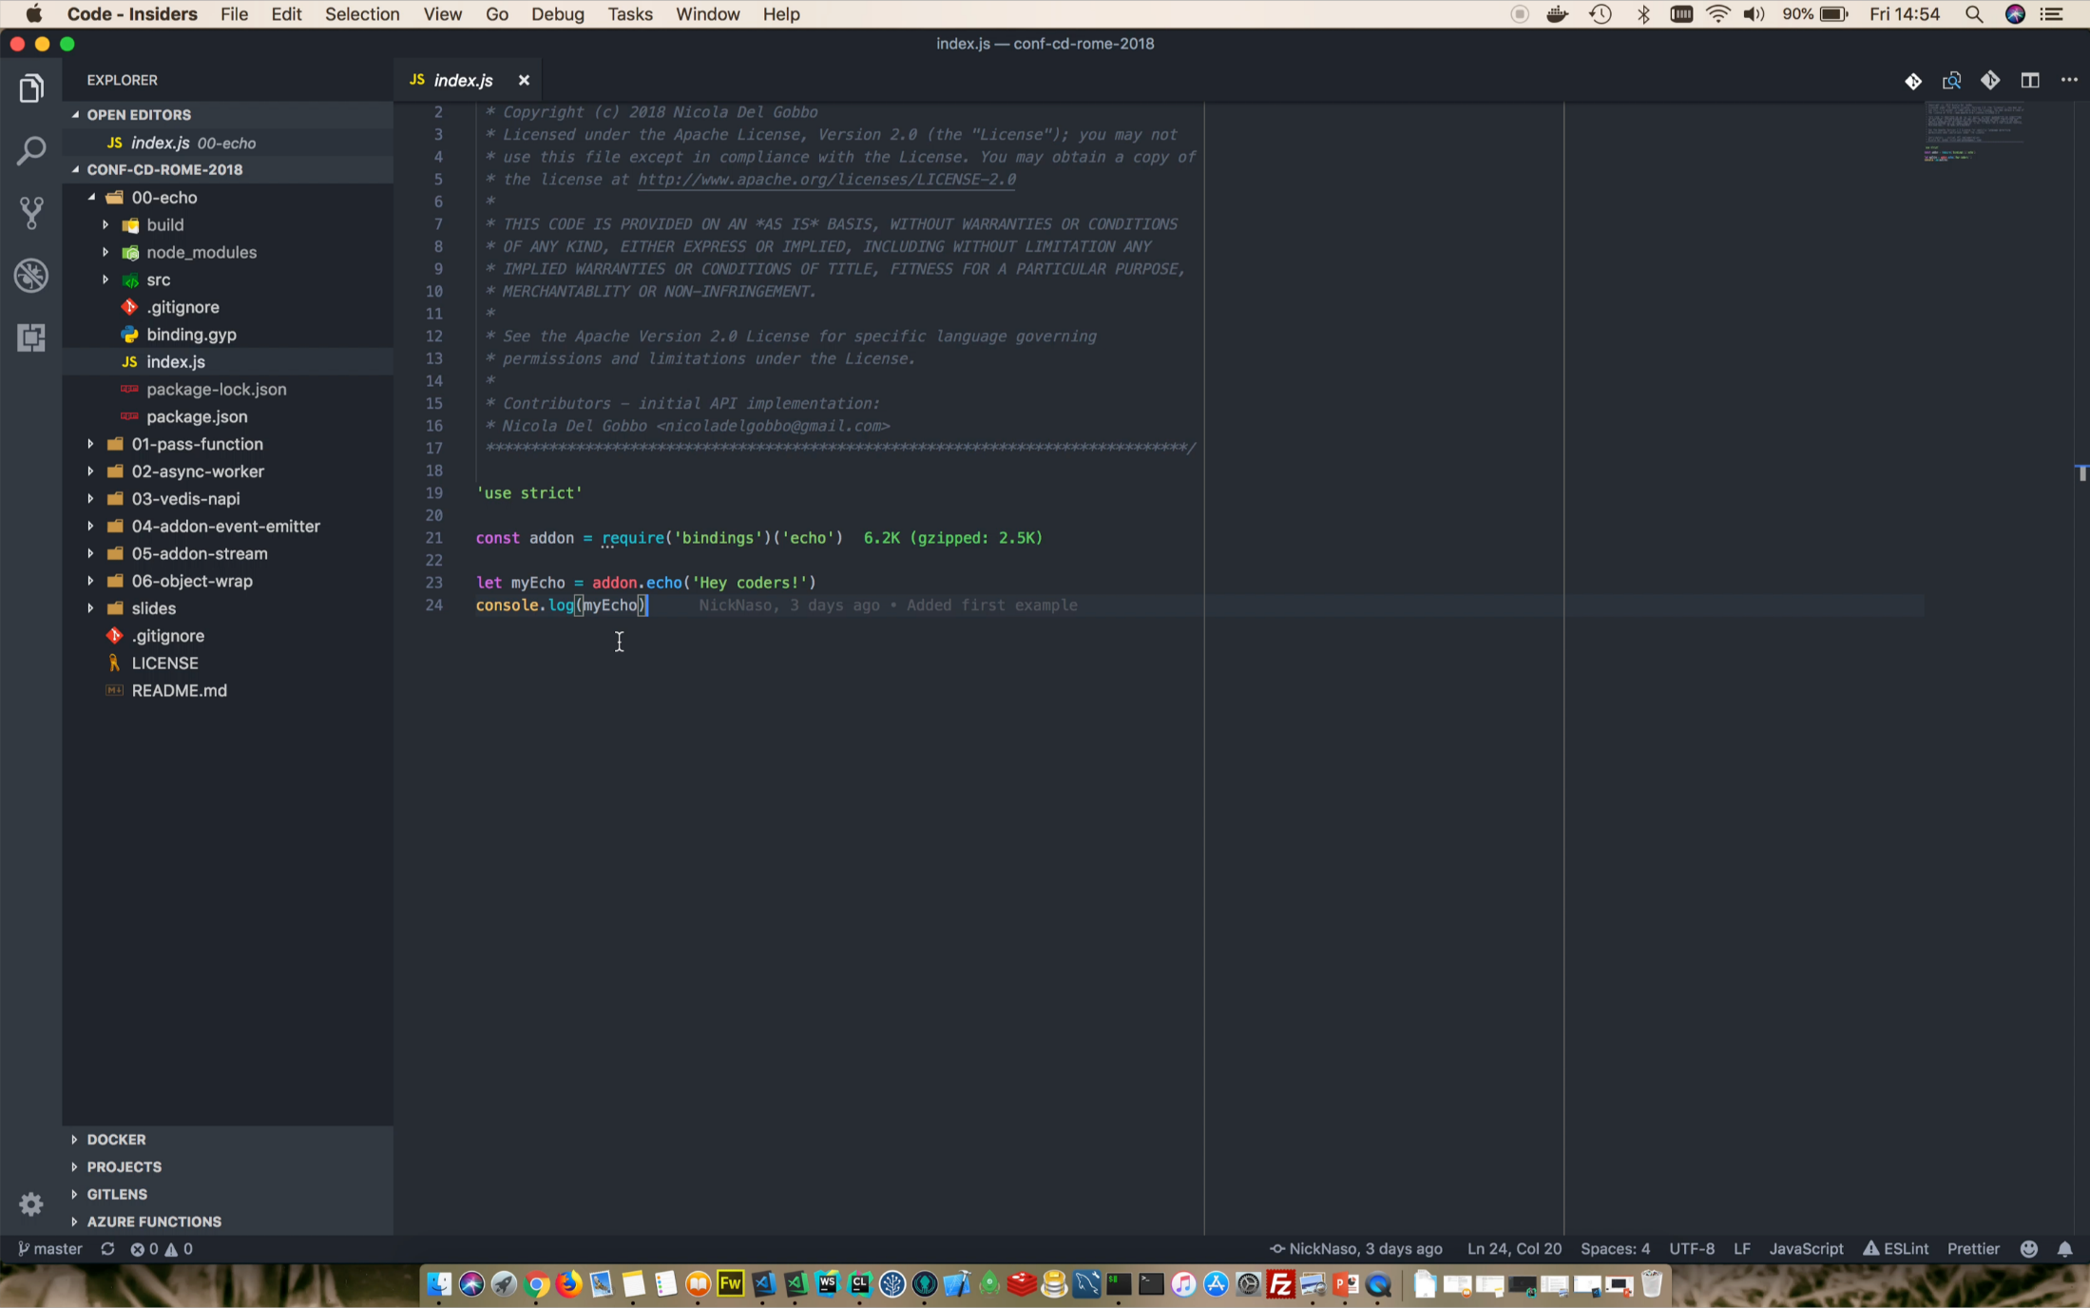

const addon = require(•bindings•)(•echo• )

function callback(err, data){

if (err){

console.error(err)

}els,e {

console.log(data)

}

}

addon.echo(•Hey coders!•, callback) 2

console.log(•My next code •..• ) 1

void Echo(const Napi::Callback!nfo& info){ Napi::Env env = info.Env();

*/1 You need to check the input data here*

Napi::Function cb = info[l].As<Napi::Function>();

std::string in = info[0].As<Napi::String>();

*/1 std::this_thread::sleep_for(std::chrono::seconds(l));*

*/1 In case of error*

*/I Napi::Error::New(env, "Error* •••"J.*Value(*J

**Calli a callback and return the result back**

cb.Call({env.Null(), Napi::String::New(env, in)});

}

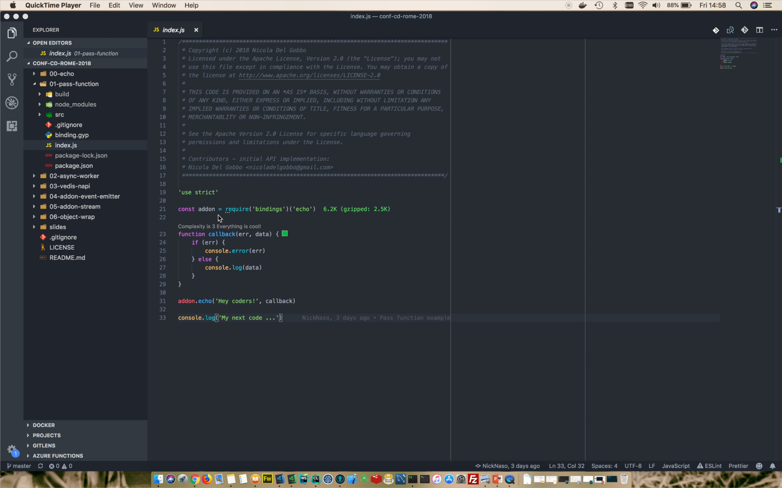

**Preserve reference to function we want call**

**Create worker threads using libuv**

**Handle the results**

class EchoWorker : public Napi::AsyncWorker {

public:

EchoWorker(Napi::Function& callback, std::string& echo)

: Napi::AsyncWorker(callback), echo(echo){}

EchoWorker() {}

**1**

**This code will be executed on the Worker Thread**

*II This code will be executed on the worker thread*

void Execute() {

*II Need to simulate cpu heavy task* std::this_thread::sleep_for(std::chrono::seconds(l)); *II std::cout <<echo<< std::endl;*

}

2

**When the Execute method ends its computation the results**

**will be reassembled and passed to JS context**

void OnOK() {

Napi::HandleScope scope(Env());

Callback().Call({Env().Null(), Napi::String::New(Env(), echo)});

}

private:

std::string echo;

};

Napi::Value Echo(const Napi::Callbackinfo& info) {

// *You need to check the input data here*

Napi::Function cb = info[l].As<Napi::Function>();

std::string in = info[0].As<Napi::String>();

**Create AsyncWorker**

EchoWorker* wk =new EchoWorker(cb, in);

wk->Oueue():

2 **Return immediately**

return info.Env().Undefined():

}

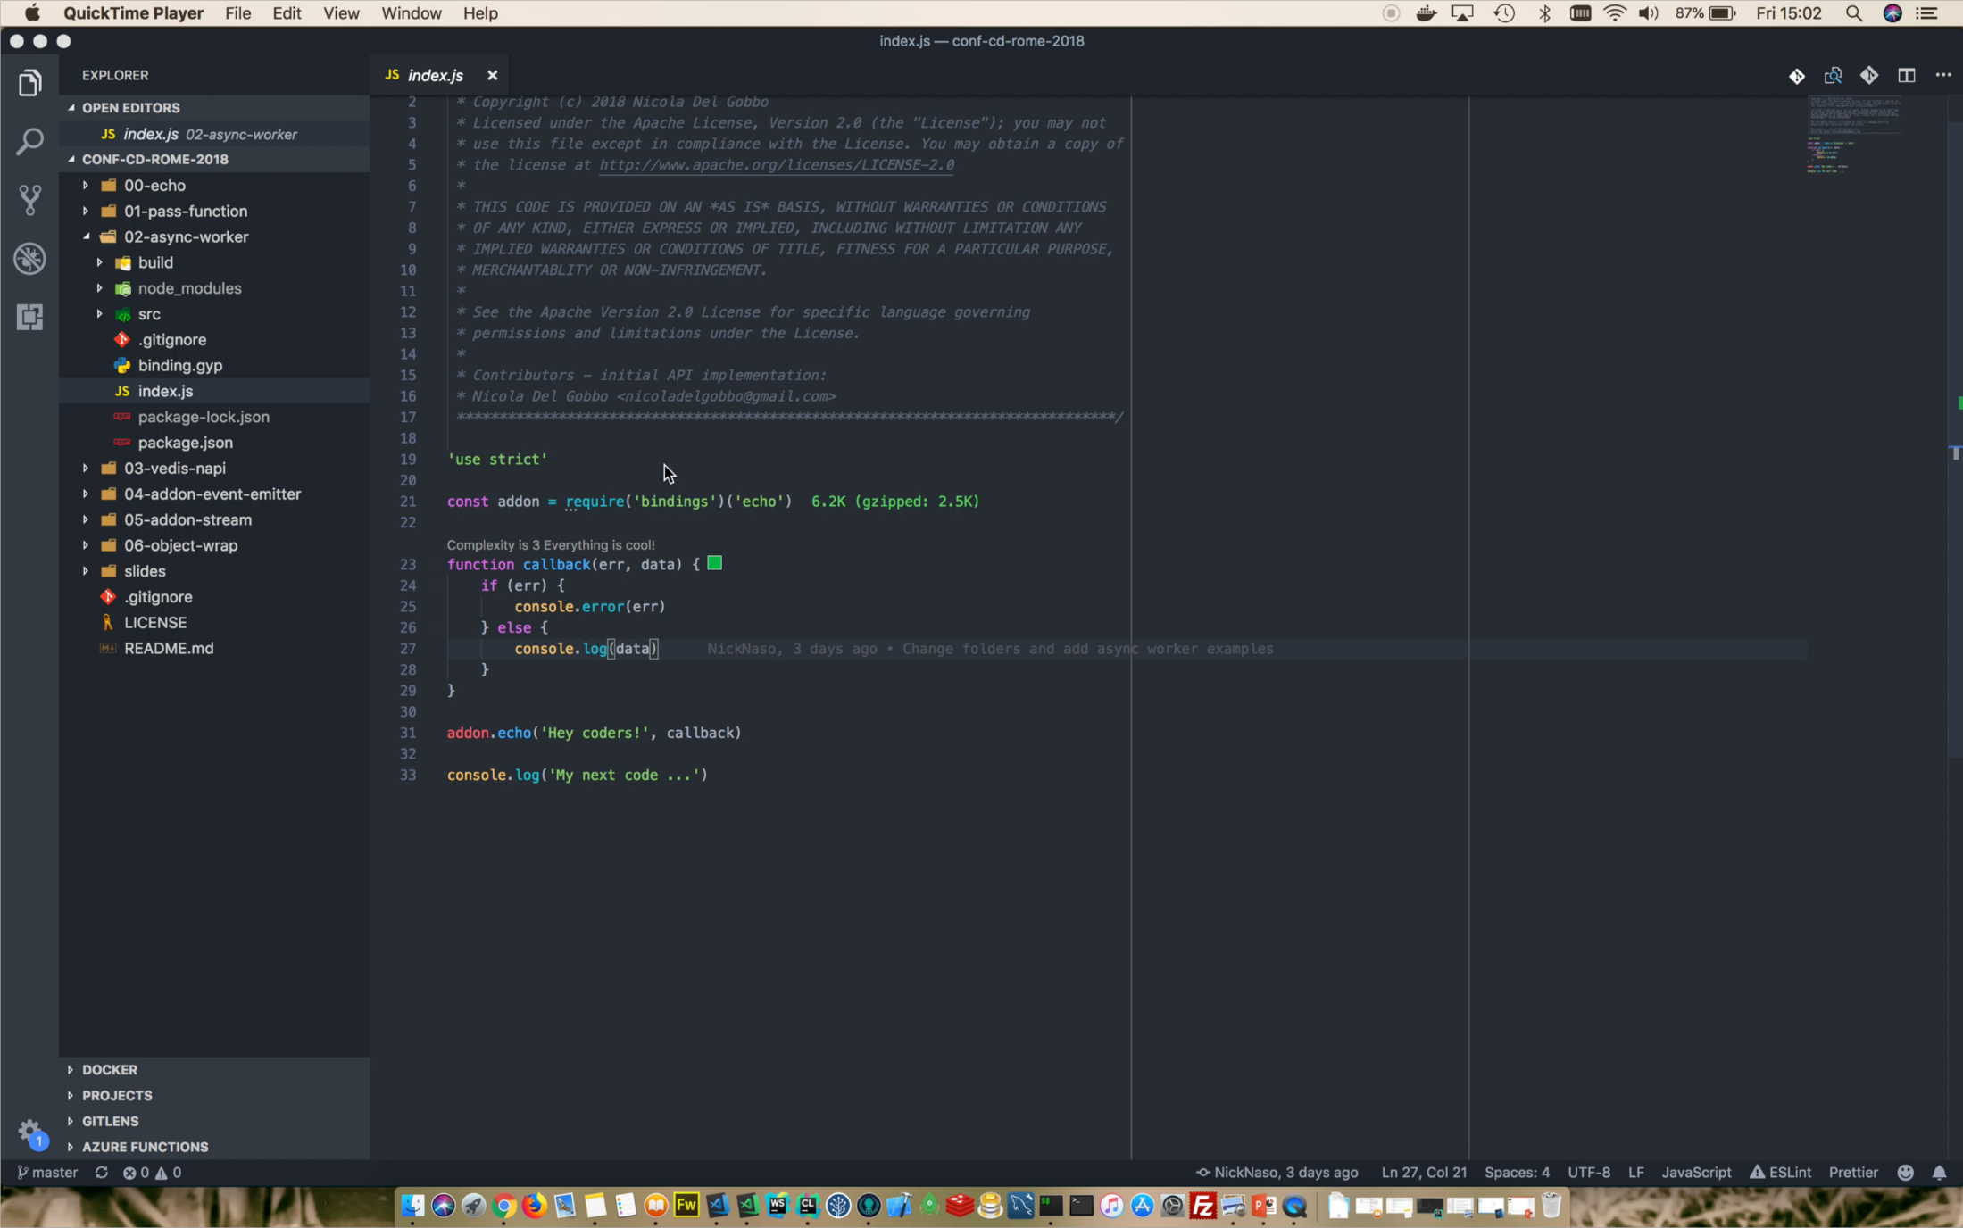

You cannot call JavaScript function from the Worker Thread

until this PR will be landed

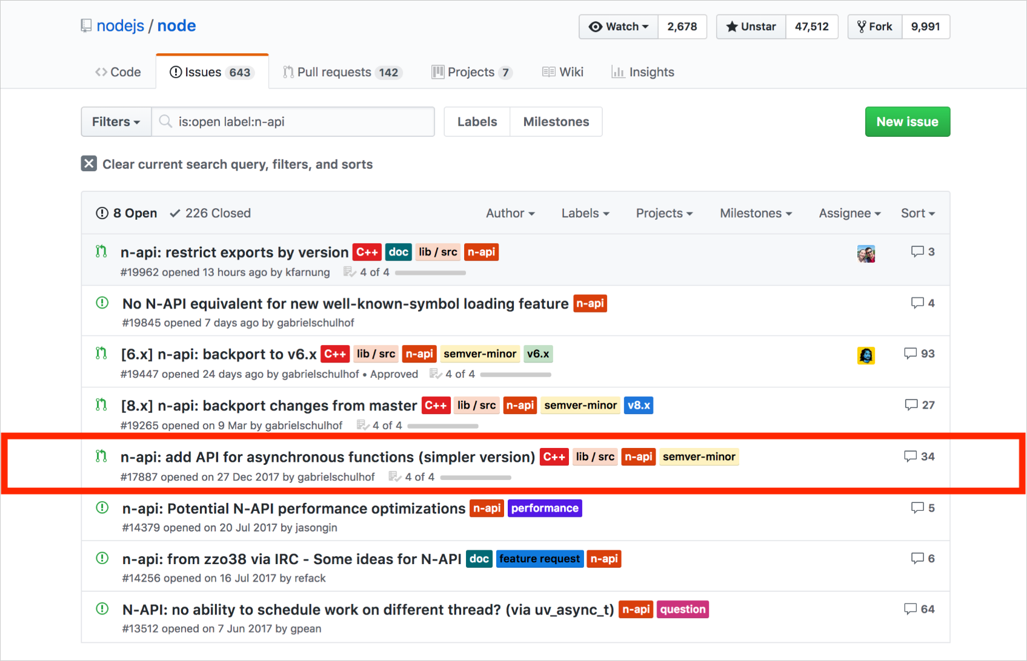

• **ObjectWrap** is a way to expose your C++ code to JavaScript

• You have to extend **ObjectWrap** class that includes the plumbing to connect JavaScript code to a C++ object

• Classes extending **ObjectWrap** can be instantiated from JavaScript using the **new** operator, and their methods can be **directly invoked from JavaScript**

• Unfortunately, the ***wrap*** part really refers to a way to group methods and state

• It’s **your responsibility write custom code to bridge** each of your C++

class methods.

Much of the Node.js core API modules are built aroud an idiomatic asynchronous event-driven architecture in which certains kinds of objects (called **emitter**) periodically emit named events that cause Function objects ("listeners") to be called.

• Emit event from **C++**

• Implement a native add-on object that inherits from Event Emitter



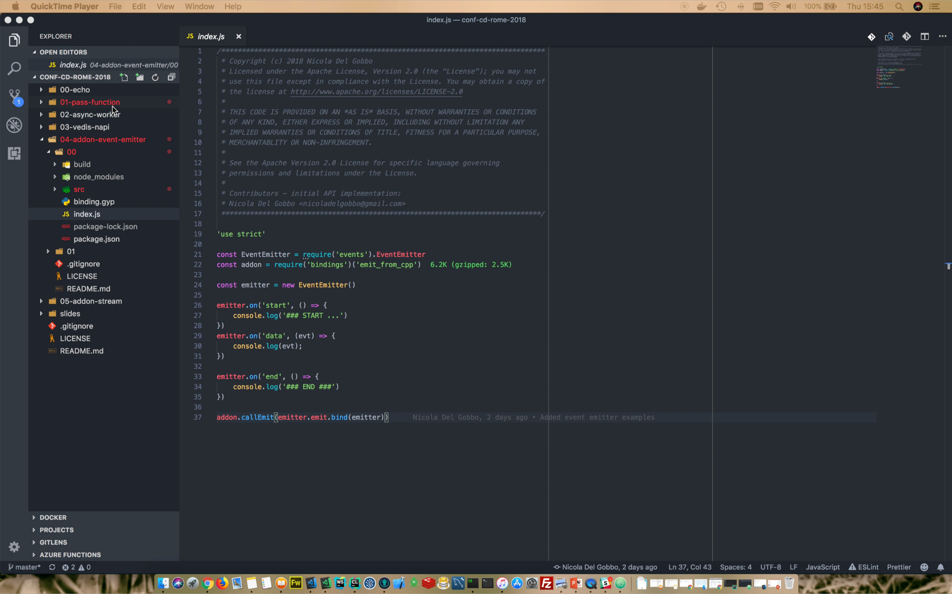

A stream is an abstract interface for working with streaming data in Node.js. The stream module provides a base API that makes it easy to build objects that implement the stream interface.

Using **Transform** stream to pass and get back data from a native add-on

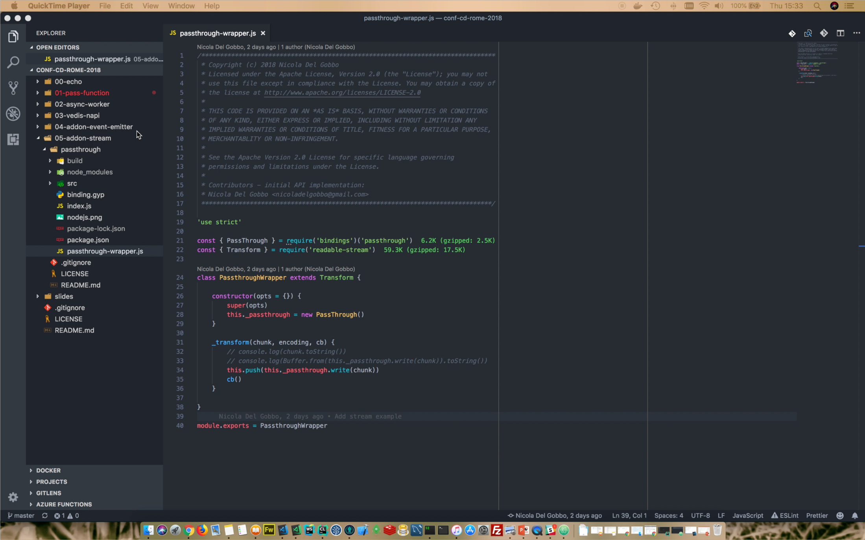

• Create **simple interface** between C / C++ and JavaScript

• Think **carefully at JavaScript** interface

• Use **ObjectWrap** API to return C / C++ object to JavaScript

• Validate the **types** on the native side

• Expose **only the functionalities you need**

• **Don’t block the event loop**, stay **asynchronous**: this is a must if you will use the add-ons in high performance services

• Use **Buffer** to pass big quantity of data

• The largest number of native add-ons is written using **NAN**

• N-API will be go out of experimental very soon

• Backports for 8.x

• Backports for 6.x

• Documentation for **node-addon-api**

• Porting preexistentes native addon-ons to N-API

• Investigate how to use prebuild with N-API

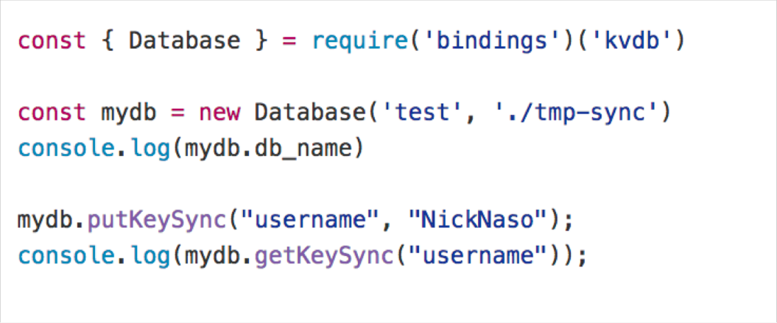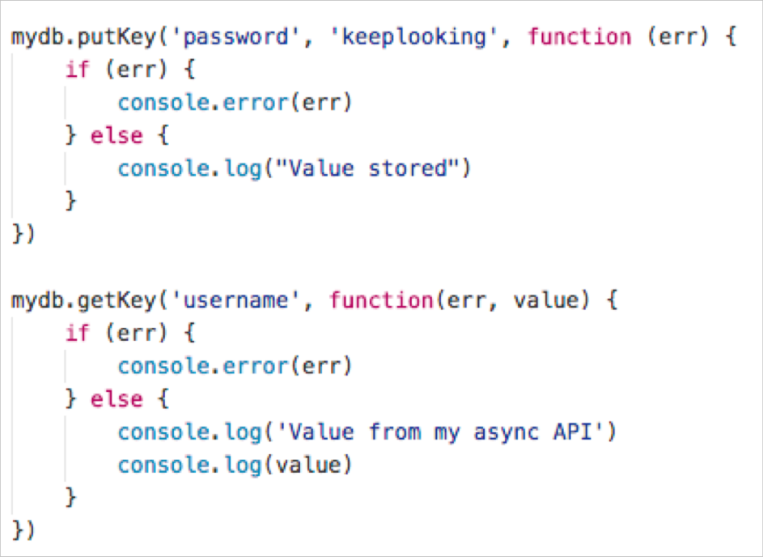

Binding to **Vedis** an embeddable datastore **C** lib

